First name and surname

Title

Master Thesis

in the Area Supply Chain Management

1st Supervisor: [Prof. Dr. Mustermann]
2nd Supervisor: []

Master of Science (M. Sc.) in Business Administration
Faculty of Economic and Social Sciences
University of Cologne

Cologne, (date of submission)

Table of Contents
List of figures III
List of tables IV
List of symbols V
List of abbreviations VI
1 Introduction (Format „Heading 1“) 1
2 Main body 1
2.1 Formal requirements 1
2.2 Other sub-sections follow... 2
2.3 Other sub-section 2
2.4 An example of a table 2
2.5 Submission 3
2.6 Citations 3
2.6.1 Citations in the text 3
2.6.2 Reference list 4
2.7 Listings/Numerations 4
3 Conclusion and outlook 5
Reference list 6
Appendix 8

List of figures
Figure 1: Model-Free Evidence on Idea (Over) Valuation 2

List of tables
Table 1: Sales quantity of Zoo T-Shirts per month 2

List of symbols
α | Ratio of people visiting the zoo once a year
µ_{age} | Average age of people visiting the zoo
...
...
...
...
...
...
...
...
...
...
...
...

List of abbreviations
All abbreviations that are used in the master thesis have to be listed here. Common abbreviations, such as “etc.”, should not be listed. All abbreviations need to be introduced when used for the first time in your thesis.
The following list can be used as a template. After listing all abbreviations, you should delete spare lines, select the entire table and then arrange the components of the table in alphabetical (ascending) order, using the tab “Layout of tables”.

CR | Critical Ratio
DC | Distribution Center
DimWt | Dimensional Weight
DP | Demand Planning
ROI | Return on Investment
...
...
...
...
...
...
...
...

Introduction (Format „Heading 1“)
Usually, the format “Standard“ is used for the text. All other format templates should be self-explanatory.
For further information regarding theses at the WiSo-Faculty, please visit the website of the examination office (“WiSo-Prüfungsamt“).
For examination regulations of 2015, please click this link:
https://www.wiso.uni-koeln.de/de/fakultaet/dekanat/pruefungsaemter/po-2015/abschlussarbeiten/,
For examination regulations of 2008, please click this link:
https://www.wiso.uni-koeln.de/de/fakultaet/dekanat/pruefungsaemter/po-20072008/abschlussarbeiten/
(Status: 10.03.2021)

Main body
There always has to be a (mostly introductory) text between two headings. Please note that a new chapter does not have to start on a new page. The main body usually consists of more than one chapter.

Formal requirements
You should use double-spacing, a serif font (such as Times New Roman) with a size of 12pt and the format “full justification” (“Blocksatz”).
The margins of the pages have to be set as follows: Left: 4 cm, Right: 2.5 cm, Upper: 2.5 cm, Lower: 2.5 cm.
All pages have to be numbered consecutively. For the pages prior to the introduction, you should use Roman numbering (I, II, III, ...). However, please note that even though the front page counts as a page, it should not be numbered. For the pages starting with the introduction you have to use Arabic numbers (1, 2, 3,…).
The master thesis should be up to 60 pages (excluding table of contents, list of abbreviations, list of tables and figures, references and appendix). All figures and tables in the main body are included in the 60 pages.

Other sub-sections follow...
Each sections should have at least two sub-sections, meaning that 2.1 has to be followed by 2.2.

Other sub-section
The figures should be inserted using the button „Insert picture from file“. Afterwards, they should be centered. See Figure 1.
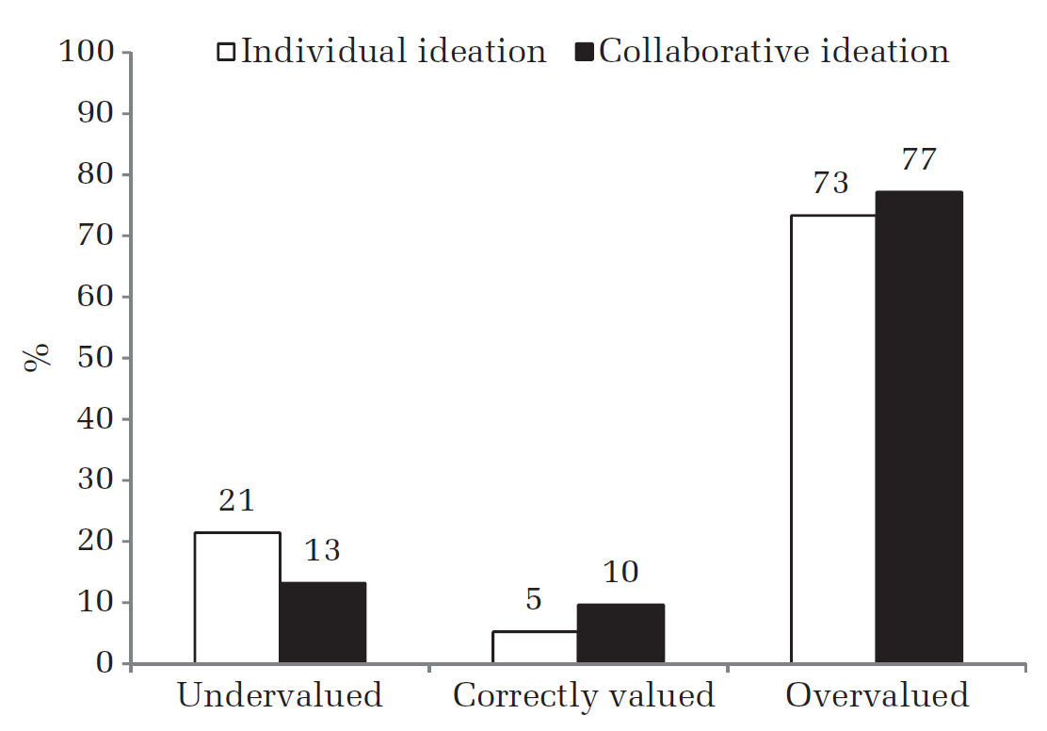
Figure 1: Model-Free Evidence on Idea (Over) Valuation

The caption for the figure in the following line has to be generated via the format „Caption“. This formatting is necessary for the List of Figures and Tables. To create a caption, go to the tab „Reference“, then click „Insert Caption“. Select „Figure“ or „Table“ and fill in the description.

An example of a table
Size | μ | σ
M | 40 | 20
L | 40 | 20
XL | 100 | 40
Table 1: Sales quantity of Zoo T-Shirts per month
The labelling of tables follows the same procedure as the one for figures and should be consistent. The caption is either placed below or above the table and should be formatted as „Caption“ (see 2.3 for an instruction). All used figures and tables have to be mentioned in the text (e.g. see Table 1) and should be numbered sequentially with Arabic numerals throughout the thesis. The corresponding reference can be inserted via „Insert Cross-Reference“. The source of figures and table must be given in parentheses at the end of the caption. If a figure or table is adapted from another source, it should also be noted.

Submission
Please always check the current guidelines on the Website of the examination office (https://wiso.uni-koeln.de/de/fakultaet/dekanat/pruefungsaemter/po-2015/abschlussarbeiten).
In addition to the official submission at the examination office, we would like you to also send your master thesis in digital form (pdf-format) to your supervisor (no formal requirement).

Citations
The use of knowledge from external sources has to be labelled with a reference to the author, the year of publication and the page number. Corresponding to that, the source has to be mentioned in the Reference List.

Citations in the text
For all citations in the text, please use the Harvard citation style. In the case of word-for-word reproduction, you have to use quotation marks before and at the end of the quotation. If content is only indirectly reproduced in own words, no quotation marks are needed. However, you should make clear that the knowledge and the ideas you are using are not your own. You do that by inserting the reference at the end of your sentence as follows:
- Surname of the author (if there are two authors, both names are connected with “and”; if there are three or more authors, only the surname of the first author is mentioned and “et al.” is added)
- Year of publication, e.g. 2009
- Page number (with abbreviation “p.” for page)
If you are referring to the general claim of a paper, the page number is not necessary. If you are quoting something word-for-word, make sure that it emphasizes your statement in a significant way, otherwise please stick to quoting indirectly.
Examples:
- Human behavior, such as misunderstandings concerning information about storage and demand, can cause the bullwhip-effect (Sherman 1989, p.34).
- Lee et al. (1997) analyzed four sources of the bullwhip-effect ...
- According to Cachon and Lariviere (2001), “Firm commitments are not useful for aligning incentives but are useful for communication information” (p. 643).
When using academic literature, make sure to use primary sources, secondary data is only allowed under certain circumstances and should be discussed with your supervisor.

Reference list
The literature has to be arranged in alphabetical order by the name of the first author. If one author has several publications, the year of publications is used for sorting. In the case of several publications in the same year, lower case letters are used (e.g. “Thonemann 2001a”). You can find examples for quoting different sources in the Reference List of this text.

Listings/Numerations
For numerations or listings, you can use either bullet points or Arabic numbers.
The first possibility looks as follows:
- …
- …
The second possibility looks as follows:
- …
- …

Conclusion and outlook
The fundamental findings of the master thesis are summarized at the end. The outlook is used for referring to possible future developments and research directions.

Reference list
The Reference List is not created separately for different kinds of sources (books, papers, websites, etc.). The sources are only listed separately here to clarify how different types of sources need different citations. Please also refer to Section 2.6.2.
In order to simplify the management of literature, there are specific literature management programs, such as Citavi, Zotero or Mendeley with plug-ins or add-ins for Word. We highly recommend using such programs.
As an alternative, you can use the literature management of Word that allows you to create a reference list automatically.

Articles in journals and magazines
Fisher, M.L., Raman, A., McClelland, A. 2000. Rocket science retailing is almost here – Are you ready? Harvard Business Review 78(4), 115-124.
Sterman, J.D. 1989. Modeling managerial behavior: Misperceptions of feedback in a dynamic decision-making experiment. Management Science 35(3), 321-339.
Tversky, A., Kahneman, D. 1974. Judgment under uncertainty. Heuristics and biases. Science 185(4157), 1124-1131.
Articles in reviewed editions and Proceedings
Bolotin, V. 1994. Telephone circuit holding-time distributions. J. Labetoulle, J. W. Roberts, eds. Proceedings of the International Teletraffic Congress, ITC 14. North-Holland, Amsterdam, Netherlands, 125–134.
Cachon, G. P. 2003. Supply chain coordination with contracts. S. Graves, T. de Kok, eds. Handbook of Operations Research and Management Science: Supply Chain Management. Elsevier, Amsterdam, Netherlands, 227–339.
Kahneman, D., Frederick, S. 2002. Representativeness revisited. Attribute substitution in intuitive judgment. T. Gilovich, D. Griffi, D. Kahneman, eds. Heuristics and biases. The psychology of intuitive judgment. Cambridge University Press, New York, 49–81.

Books
Cachon, G. P., Terwiesch, C. 2009. Matching supply with demand. An introduction to operations management. 2nd ed. Irwin/McGraw-Hill, Boston, MA.
Hopp, W., Spearman, M. 1996. Factory physics. Irwin/McGraw-Hill, New York.
Thonemann, U. 2010. Operations Management. Konzepte, Methoden und Anwendungen. 2nd ed. Pearson Studium, München.
Working Papers
Schultz, K. L., McClain, J. O., Robinson, L. W., Thomas, L. J. 2007. The use of framing in inventory decisions. Working paper, Cornell University, Ithaca, NY.
Websites
Supply Chain Council. 2013. Supply Chain Operations Reference (SCOR) model – Overview – Version 10.0. Available online at https://supply-chain.org/f/SCOR-Overview-Web.pdf, checked on 26/02/2018.

Appendix
The appendix lists all explanations, figures and tables that are not needed to understand the main body but provide additional insights. Examples could be further explanations of specific concepts or data that is mentioned only for the sake of completeness. Every element from the appendix must be referenced within the main text. Formal requirements concerning the main text are valid for the appendix as well.
In the case of extensive documentation (e.g. program code or questionnaire), it can be agreed on an individual exception (e.g. appendix on a DVD).
If the appendix includes more than one point, you should put the different points in order (Appendix A, Appendix B, Appendix C,...).

Statutory declaration
The form for the statutory declaration can be found on the website of the examination office:
https://wiso.uni-koeln.de/sites/fakultaet/dokumente/PA/formulare/eidesstattliche_erklaerung.pdf
The statutory declaration should not be integrated into the printed version. Instead, it should be printed out separately, filled in and enclosed as a loose paper.

